ELEMENTARY TRACK & FIELD MEET

When: Tuesday, June 5, 2018

Where: GRB High School Track

Interested students should sign up in class and return this permission slip to their physical education teacher.

Transportation will be provided from the elementary schools to the High School at 1:55. The meet will begin at approximately 3:00. Transportation from the High School home, after the meet (approximately 4:15) is the responsibility of the family. The Booster Club concession stand will be open.

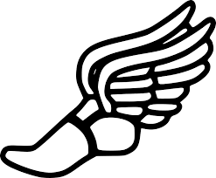

- - - - - - - - - - - - - - - - - - - - - - - - - - - - - - - - - - - - - - - - - - - - - - - - - - - - - - - - - - - - - - - - - - - - - - -

Child’s Name:__________________________________

Classroom Teacher:_____________________________ Grade:_________

My child has my permission to participate in the 5/6 grade track & field meet.

I will arrange transportation from the High School home at 4:15.

________________________________ ________________________________

(Parent/Guardian Signature) (Phone Number)

