Partner Throw Sit ups

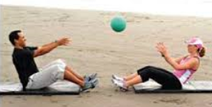

[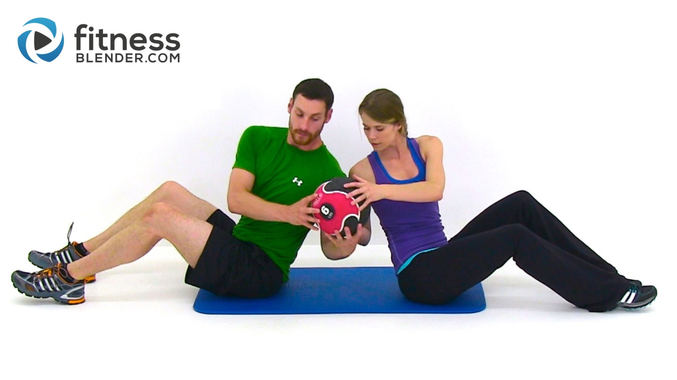](https://www.fitnessblender.com/videos/partner-workout-100th-free-full-length-workout-video-with-daniel-and-kelli)Partner Trunk Twist 2 hands

Plank Hockey

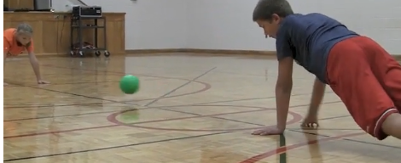

Try to score a goal!

Partner Plank Fives

[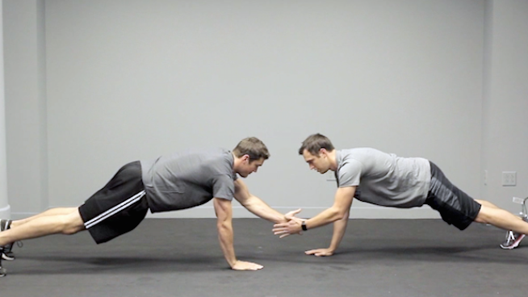](http://www.google.com/url?sa=i&rct=j&q=&esrc=s&source=images&cd=&cad=rja&uact=8&ved=0ahUKEwj5oNyO0dHTAhUGvBoKHRf2BlQQjRwIBw&url=http://www.stack.com/a/mix-up-your-workout-with-unique-partner-exercises&psig=AFQjCNF9yZKf4Xv3W_5uixm7RGcxpre8uQ&ust=1493829071652728)

Partner Wall Sit Pass

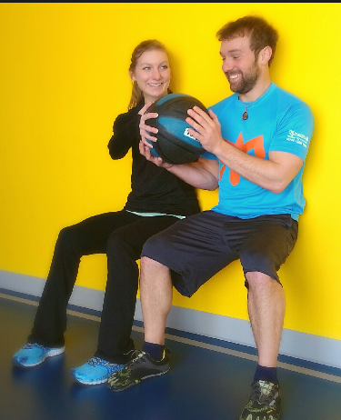

Partner Jog Around Track



Mirror Jumping Jacks

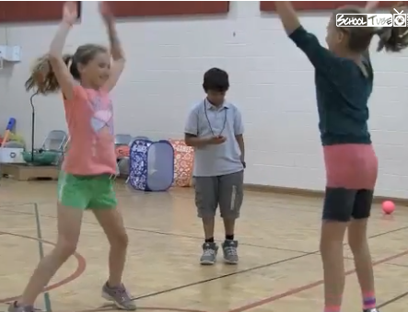

Slide and Catch

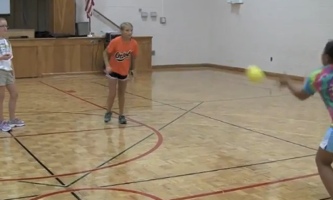

Partner Back to Back Squats

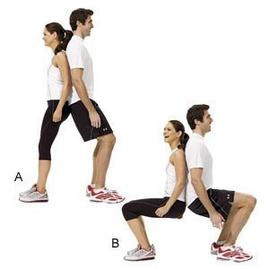

Partner Squats Holding Hands

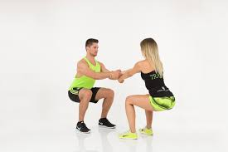

Wheel Barrow

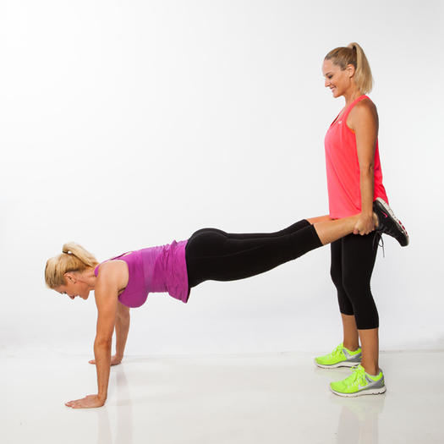

Squat High Fives

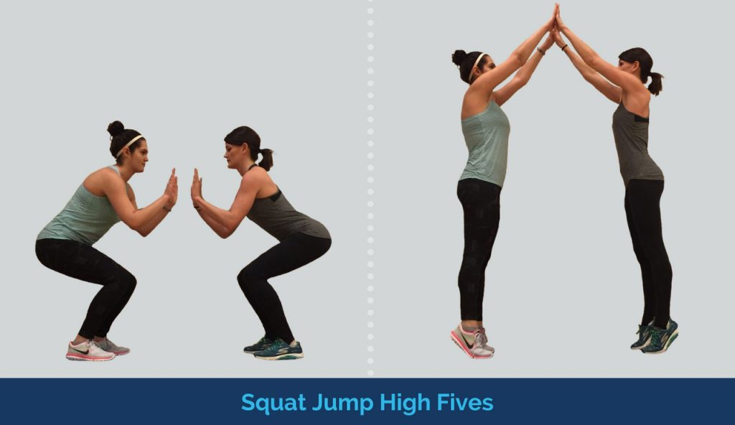

Ball Pass Feet Up

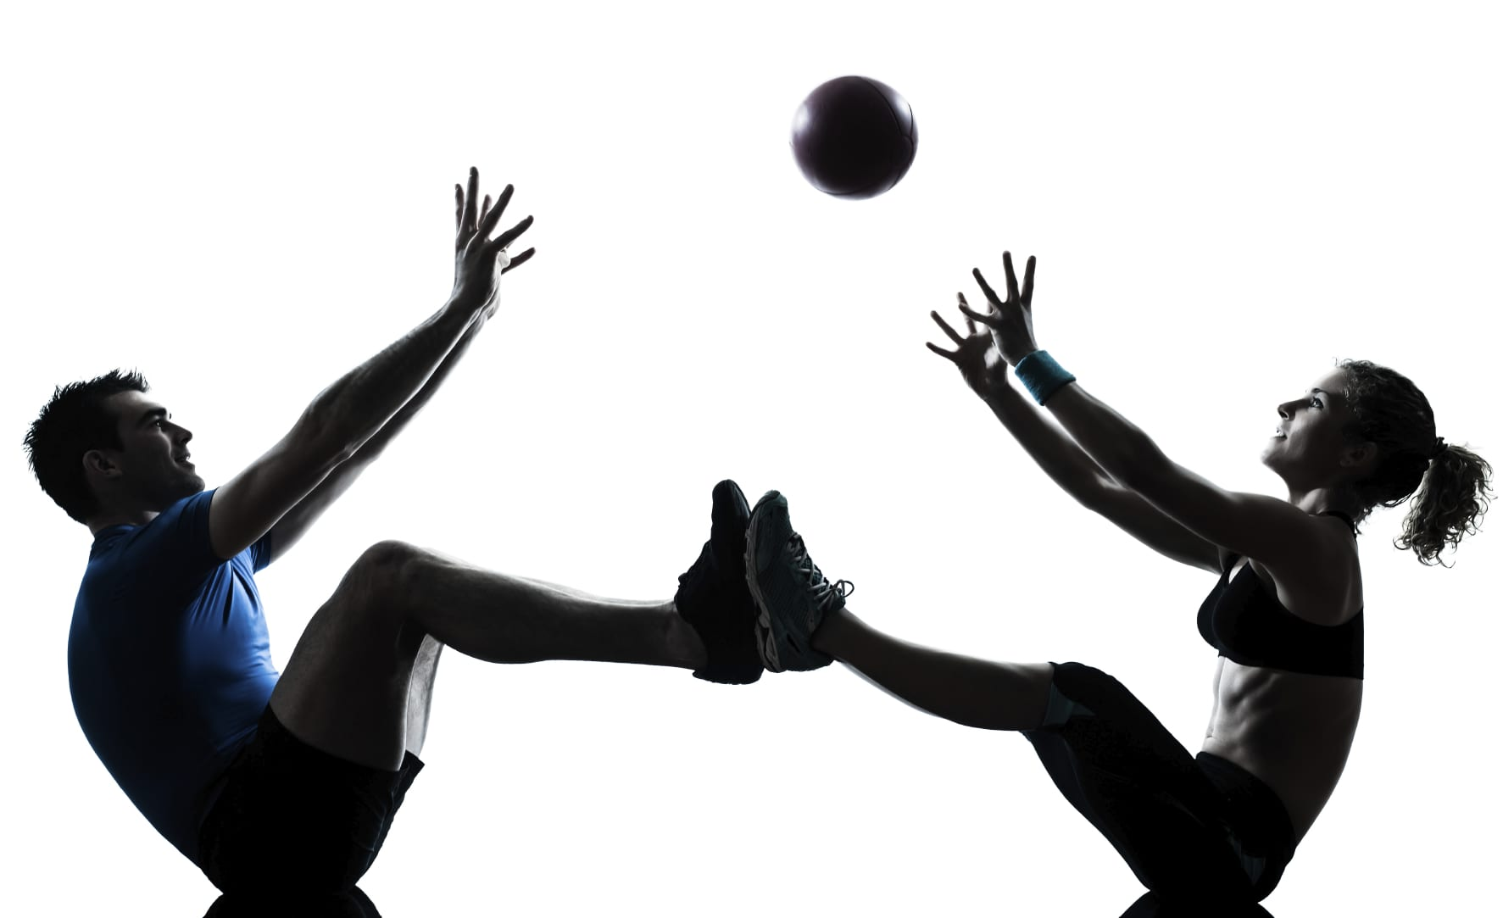

Medicine Ball Pass

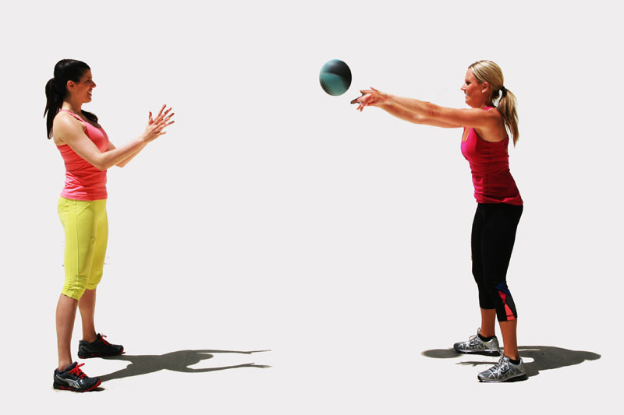

You Lay Them Down & You Stand Them Up

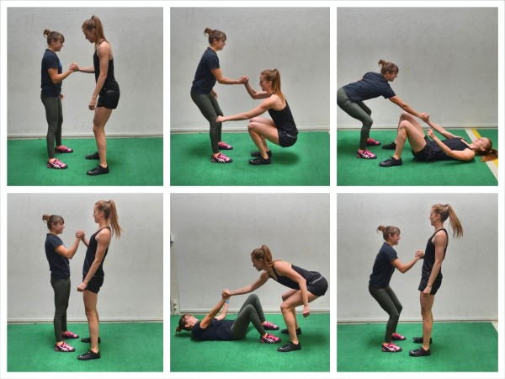

Crab

Feet Fives

